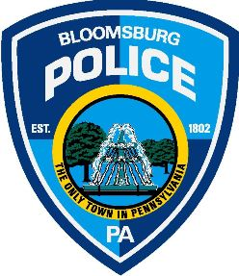

BLOOMSBURG POLICE DEPARTMET

PARKING ENFORCEMENT

PRESS RELEASE: Summer Downtown Parking Permits 2017

Valid from 05/15/17 – 08/12/17

Permit is valid in all the Zone areas of the parking lots excluding

Zone G (Library Lot)

On sale 05/08/17

at the Bloomsburg Police Department

301 E 2nd Street (Town Hall)

570-784-6779

Between the hours of 8 AM – 5:30PM

Cost: $70.00

Must have the following to obtain a permit:

1. Photo ID (Driver’s license)
2. Current signed lease or utility bill.
3. Vehicle registration card

2017 Summer Session Calendar
Session I - May 22 - August 11, 2017
Session II - May 22 - June 30, 2017
Session III - July 3 - August 11, 2017

