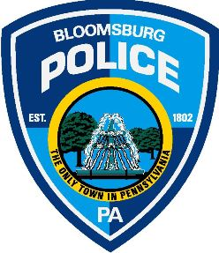

PRESS RELEASE – Bloomsburg Police Department: July 17, 2017

RESIDENTIAL PARKING PERMITS – Valid September 1, 2017 – August 31, 2018

When: Residential Parking Permits for RESIDENTS will go on sale Monday, August 7, 2017.

Residential Parking Permits for STUDENTS will go on sale Monday August 21, 2017.
(If a student is here early for sports, etc. they may get permit when they move in)

Where: Bloomsburg Police Parking Station, Town Hall Building, 301 E 2nd Street.

Hours: 8AM – 4 PM.

ALL RESIDENTS MUST BRING THE FOLLOWING:

- Photo ID

- Vehicle registration or a copy.

- Lease or a current utility bill with your name and address.

- Permits will not be issued without the above information.

- There is a $10.00 annual fee required for each vehicle permit. (2 per address)

- There is a $20.00 annual fee for the Visitor Permit. (1 per address)

- In no case shall there be more than 3 permits (two vehicle and one visitor) issued per residential unit.

There are signs on streets designating the area for the restricted residential permit parking.

The ordinance is in effect all year long.

The new decals will be effective from September 6, 2017 through August 31, 2018.

Should a resident or visitor fail to display their parking decal during the hours and days designated, a $40.00 fine shall be levied.

Call 570-784-6779 with questions.

